CSC 131
Computer Software Engineering

Software Design Document (SDD)
Project Deliverable # 3

Team Bazinga:

- Introduction

This project is a redesign of the ECS Problem Report system. It is a system that will allow external users (students, faculty) to submit a report about a bug in the system and allow them to view and update their own reports, while allowing internal users (labbies, technicians, administrators) to submit reports of their own as well as allowing them to view and modify all reports submitted to the system. The interface should be clean and concise. It must also be web based, as users will be accessing the reporting system from the ECS web site. It will be open to any user running a web-browser and a current operating system. External users will be able to submit reports and view and modify their own reports, while internal users will be able to submit reports, view, and modify all reports.

- Revised Requirements

There were no major requirement revisions during the course of the design phase and the implementation stage. The data dictionary was created for the design document as it was not included in the initial Software Requirement Specification (SRS) document.

- Data Design

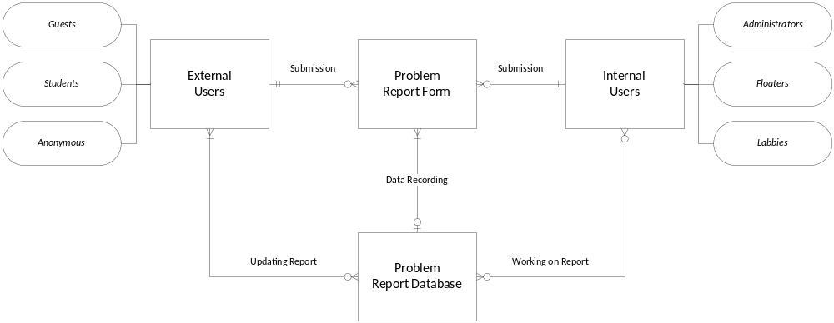

Figure 1: Entity Relation Diagram

  - Description

    - Entities

- Problem Report Form: submitted by external or internal users that details the type of problem, problem description, system type, category, due date that the user would like this problem to be fixed by, room and position, computer name, user phone number and email, as well as any additional questions.

- External Users: can only see the problem reports that they have submitted. Types of external users include guests, students, and anonymous users.

- Internal Users: have access to all problem reports that have been submitted. Types of internal users include administrators, floaters, and lobbies

- Problem Report Database: database used to store and process the information entered by the internal and external users.

    - Relationships:

- External Users and Problem Report Form:
  - An external user can have zero to many problem report submissions.
  - A problem report form can be submitted by exactly one external user.

- External Users and Problem Report Database:
  - An external user can update the information in the problem report database zero to many times.
  - The information stored in the problem report database requires one or more external users to update the report.

- Internal Users and Problem Report Form:
  - An internal user can have zero to many problem report submissions.
  - A problem report form can be submitted by exactly one internal user.

- Internal Users and Problem Report Database:
  - An internal user can work on the information in the problem report database zero to many times.
  - The information stored in the problem report database can have zero to more internal users to work on the report.

- Problem Report Form and Problem Report Database:
  - The problem report form can update data in the problem report database zero to many times.
  - The problem report database can have its data updated by at least one or more problem report forms.

    - Sequence Diagrams:

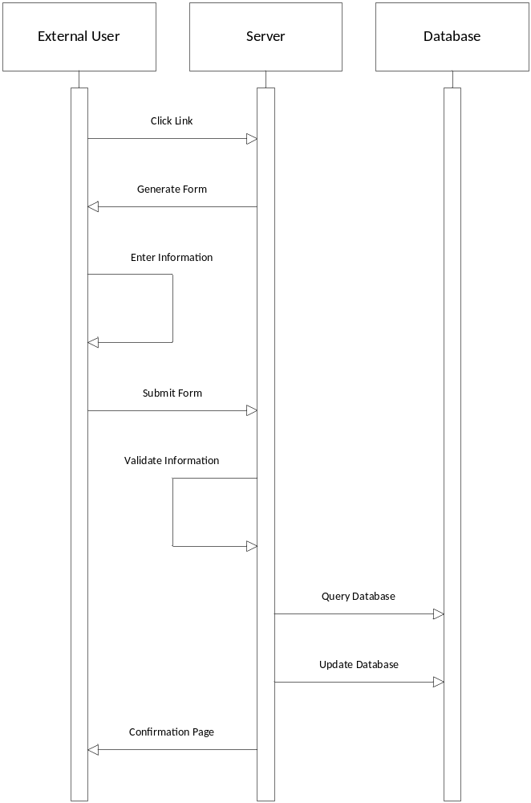

Figure 2: Report Problem Externally

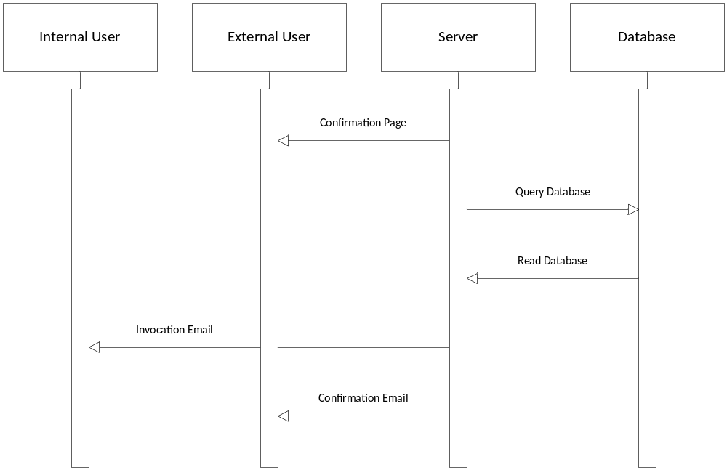

Figure 3: Report Problem External Response

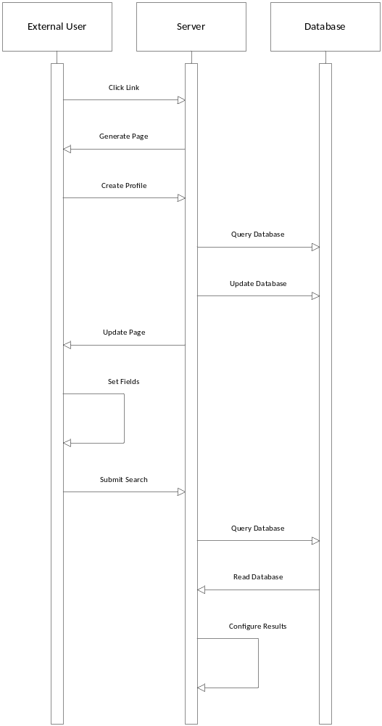

Figure 4: Report Problem Externally Searched
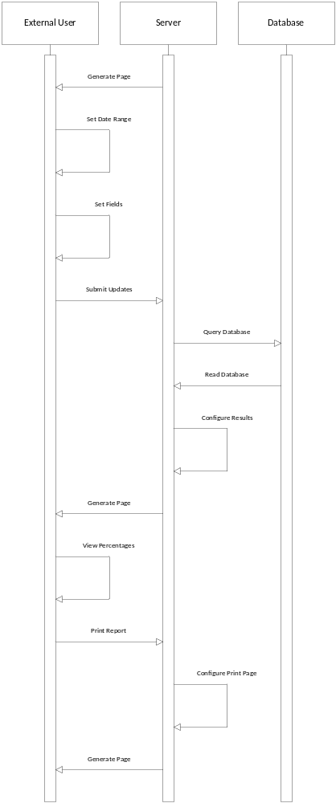

Figure 5: Report Problem Externally Viewed
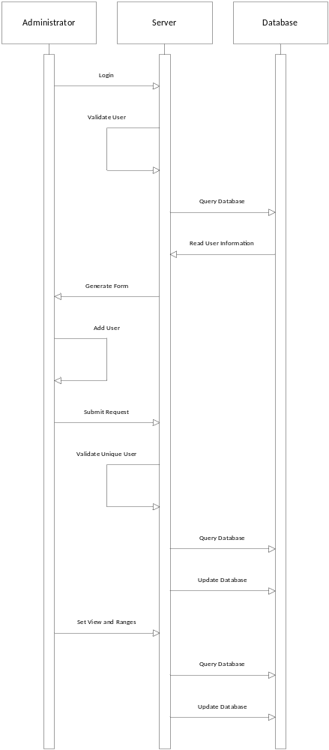

Figure 6: Manage Users and Permissions
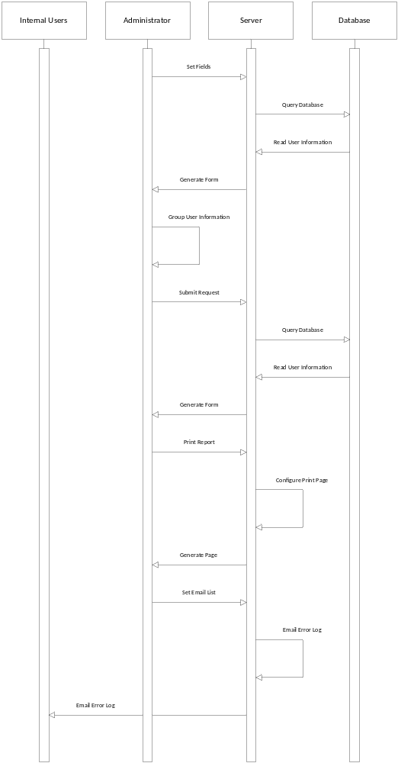

Figure 7: Reports for Administrators
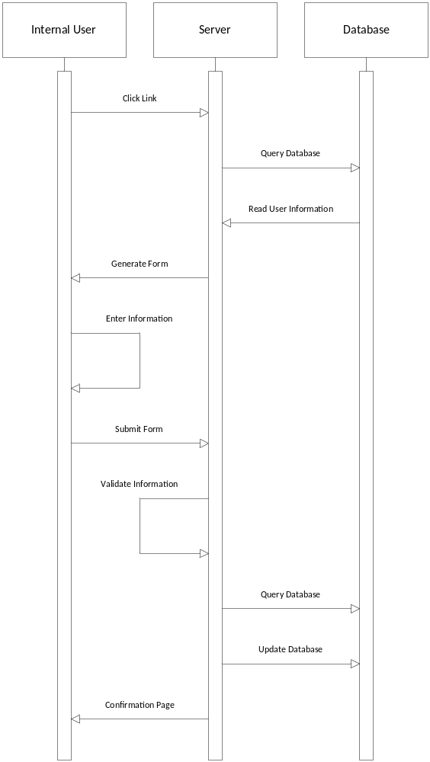

Figure 8: Report Problem Internally Reported
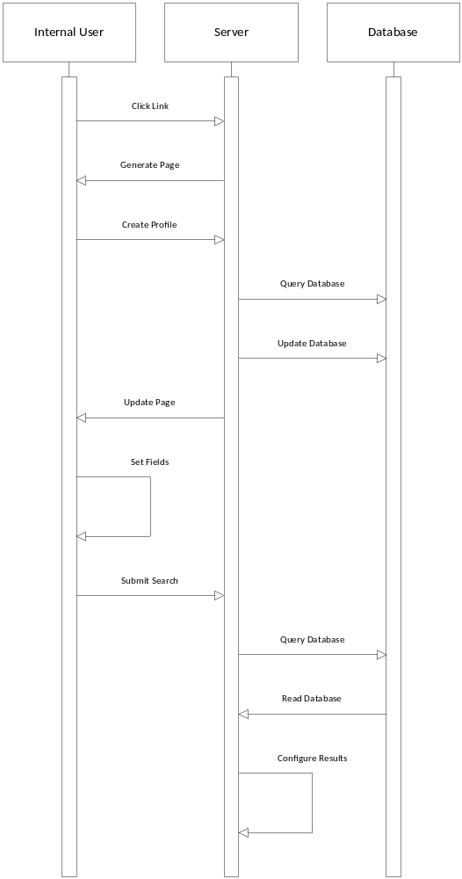

Figure 9: Report Problem Internally Searched
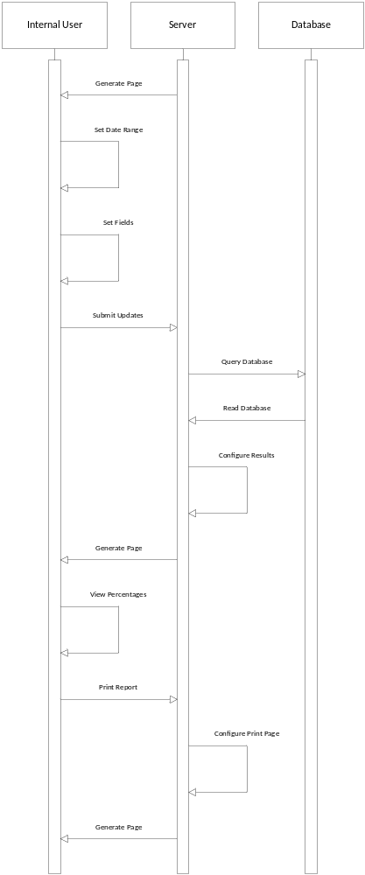

Figure 10: Report Problem Internally View Reports
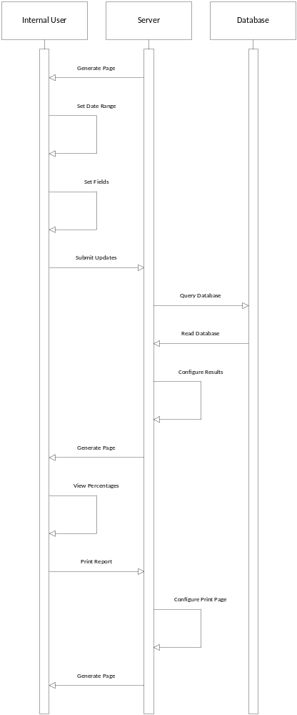

Figure 11: Report Problem Internally List Reports
    - Classes:

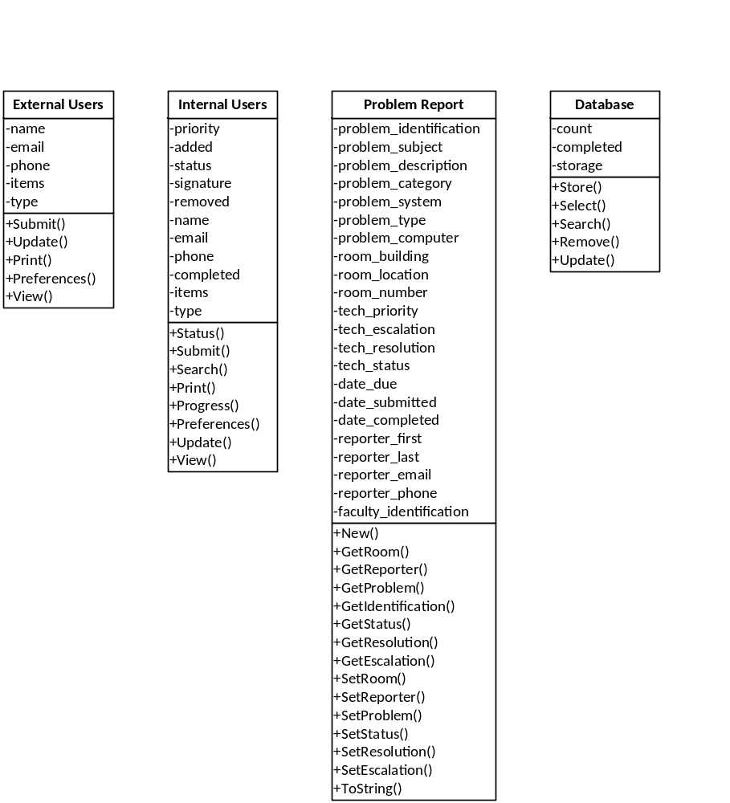

Figure 12: Class Diagrams

    - Data Dictionary:

Table | Description
Users | Stores login names and passwords.
History | Store entered values on problem report entries.
Captcha | Stores the captcha questions and answers.
Problem_Report | Stores the problem report entries.

Figure 13: Table Summaries

Name | Type | Description
Name | varchar(50) | The login name of the user.
Password | varchar(50) | The password of the user.

Figure 14: Users Table

Name | Type | Description
Problem_Identification | int(10) | The unique number of the report.
Problem_Subject | varchar(100) | The short subject description of the problem.
Problem_Description | text | The long subject description of the problem.
Problem_Category | enum | The category of the problem.
Problem_System | enum | The system used when the problem occurred.
Problem_Type | enum | The user type of the problem.
Problem_Computer | varchar(25) | The computer name of where the problem occurred.
Room_Building | enum | The name of the building.
Room_Location | varchar(50) | The position inside the room.
Room_Number | varchar(10) | The room number.
Tech_Priority | enum | The priority of the problem.
Tech_Escalation | int(1) | The escalation alert of the problem.
Tech_Resolution | text | The resolution to the problem.
Tech_Status | enum | The current status of the problem.
Date_Due | date | The due date of the problem.
Date_Submitted | datetime | The submision date of the problem.
Date_Completed | datetime | The completion date of the problem.
Reporter_First | varchar(25) | The reporter's first name.
Reporter_Last | varchar(25) | The reporter's last name.
Reporter_Email | varchar(35) | The reporter's email address for contact.
Reporter_Phone | varchar(15) | The reporter's phone number for contact.
Faculty_Identification | int(10) | The faculity identification number of the user.

Figure 15: History Table

Name | Type | Description
Captcha_Identification | int(5) | The unique number of the captcha.
Captcha_Question | varchar(500) | The stored question for the captcha.
Captcha_Answers | varchar(50) | The stored answer for the captcha.

Figure 16: Captcha Table

Name | Type | Description
Problem_Identification | int(10) | The unique number of the report.
Problem_Subject | varchar(100) | The short subject description of the problem.
Problem_Description | text | The long subject description of the problem.
Problem_Category | enum | The category of the problem.
Problem_System | enum | The system used when the problem occurred.
Problem_Type | enum | The user type of the problem.
Problem_Computer | varchar(25) | The computer name of where the problem occurred.
Room_Building | enum | The name of the building.
Room_Location | varchar(50) | The position inside the room.
Room_Number | varchar(10) | The room number.
Tech_Priority | enum | The priority of the problem.
Tech_Escalation | int(1) | The escalation alert of the problem.
Tech_Resolution | text | The resolution to the problem.
Tech_Status | enum | The current status of the problem.
Date_Due | date | The due date of the problem.
Date_Submitted | datetime | The submision date of the problem.
Date_Completed | datetime | The completion date of the problem.
Reporter_First | varchar(25) | The reporter's first name.
Reporter_Last | varchar(25) | The reporter's last name.
Reporter_Email | varchar(35) | The reporter's email address for contact.
Reporter_Phone | varchar(15) | The reporter's phone number for contact.
Faculty_Identification | int(10) | The faculity identification number of the user.

Figure 17: Problem Report Table

- Architecture Design

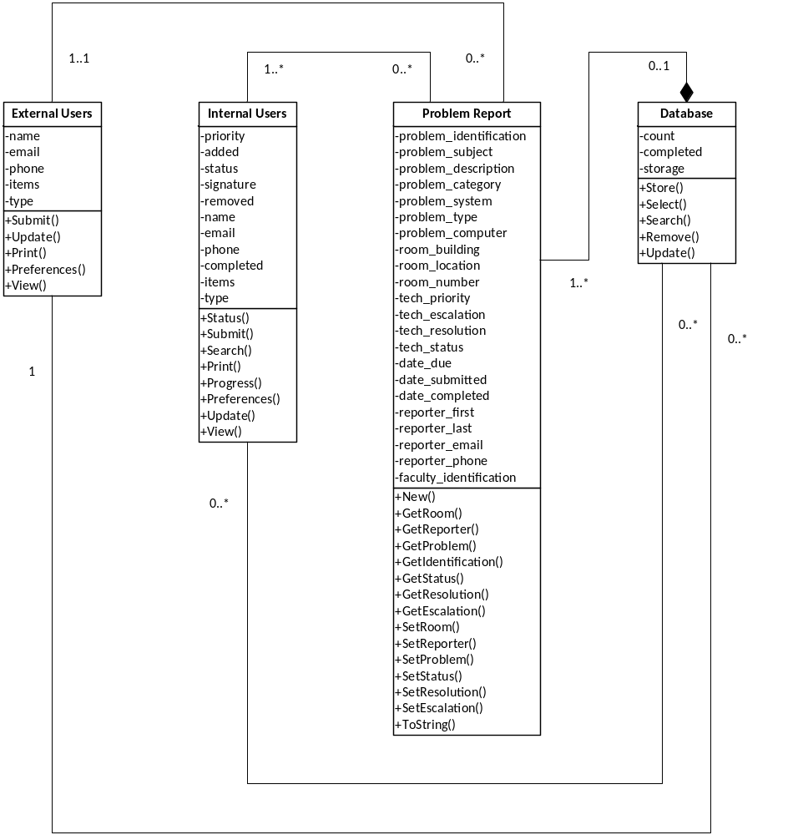

Figure 16: Class Diagram Relationships

  - Description:

The class diagram above shows the relationships between classes. The four classes include External Users, Internal Users, Problem Report, and Problem Report Database. Each class shows the attributes as well as the operations that are performed.

- Relationships:

  - Problem Report to Internal Users: one to many
  - Internal Users to Problem Report: zero to many
  - Problem Report to External Users: exactly one
  - External Users to Problem Report: one to many
  - External Users to Problem Report Database: zero to many
  - Problem Report Database to External Users: one to many
  - Internal Users to Problem Report Database: zero to many
  - Problem Report Database to Internal Users: zero to many
  - Problem Report to Problem Report Database: zero to many
  - Problem Report Database to Problem Report: one to many
  - Problem Report to Problem Report database: REQUIRED

- Detailed Class Design

Class Name | External Users
Processing Narrative | Interface for this class includes the view of the problem report form which includes options to submit an error with descriptions such as what the problem is, the date, user email address, etc. A confirmation message page is included in this class’ interface if the user submits a problem report. This class interface also includes a search page in which it can select what components of a problem report to search for which leads to the last interface for this class which is the search results page.
Pseudo Code | initialize external variables;  if unable to query database  {  kill connection;  }  grab external variables from form;  if unable to query database  {  kill connection;  }  if email is provided  {  send confirmation response and page;  }  else  {  send confirmation page;  }  close database connection;
Restrictions and Limitations | This class is not allowed to view other problem reports other than the ones submitted by them. This class is not allowed to update the status of submitted problem reports. This class is limited by the options given to them in scroll boxes on the problem report form.

Figure 17: External Users Description

Class Name | Internal Users
Processing Narrative | Interface for this class includes the view of the problem report form which includes options to submit an error with descriptions such as what the problem is, the date, user email address, etc. A confirmation message page is included in this class’ interface if the user submits a problem report. This class interface also includes a search page in which it can select what components of a problem report to search for which leads to the last interface for this class which is the search results page.
Pseudo Code | initialize internal variables;  if unable to query database  {  kill connection;  }  grab internal variables from form;  if unable to query database  {  kill connection;  }  if email is provided  {  send confirmation response and page;  }  else  {  send confirmation page;  }  close database connection;
Restrictions and Limitations | No restrictions. This class can view all and update all problem report forms. Limitations include this class may not have the knowledge to update or fix the problem report form.

Figure 18: Internal Users Description

Class Name | Problem Report Form
Processing Narrative | Page of the problem report form includes options to put in contact information including name, email address, and phone number and a problem information section that includes option to enter subject, description, category, date due, system, building, room number, room location, where, and finally a submit button.
Pseudo Code | initialize problem report form variables;  display problem subject field;  display problem description field;  display category field;  display date due field;  display room field;  display position field;  display where field;  display computer name field;  display first name field;  display last name field;  display email field;  display phone number field;  if internal user  {  display priority field;  display escalation field;  display entered by field;  }  if submit button pushed  {  begin database procedure;  }
Restrictions and Limitations | This class is limited on the information it can receive because only certain subjects are given in the problem report form to fill out.

Figure 19: Problem Report Form Description

Class Name | Problem Report Database
Processing Narrative | Database that stores all problem reports that have been submitted by external and internal users.
Pseudo Code | Not applicable. Database and tables were created and managed by an external tool, so no pseudo code was required in order to implement this system.
Restrictions and Limitations | This class is limited by the information that it is given from the other classes. This class is restricted from creating its own data.

Figure 20: Problem Report Database Description
- User Interface Design

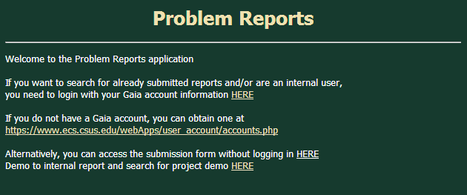

Figure 21: Problem Reports Welcome Page

This is the Welcome page. It consists of links that navigate the user to either a Gaia login page, to create a new Gaia account, an external problem report form, and an internal problem report form. The link for this site is: athena.ecs.csus.edu/~bazinga

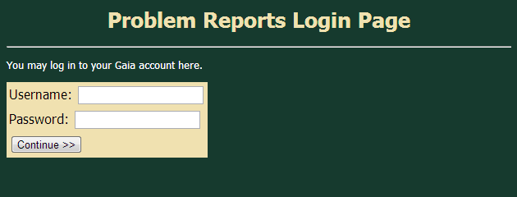

Figure 22: Problem Reports Login Page

This is the Problem Reports Login Page. The user has the ability to log into their Gaia account through this page. If the user is unable to login to their, they are redirected to a page that allows them to create a new Gaia account.
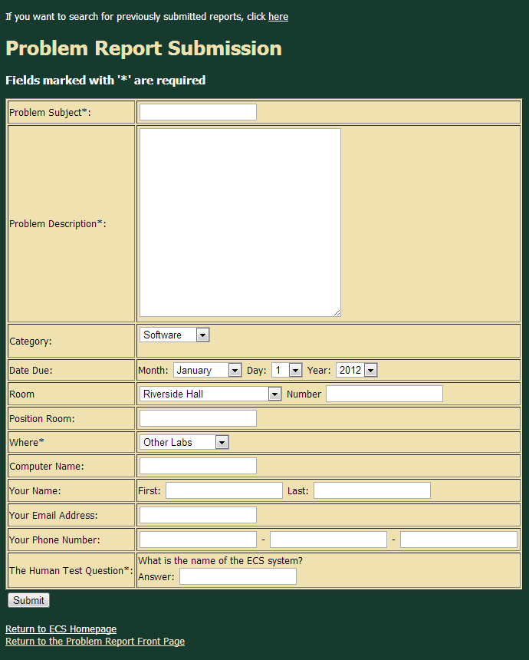

Figure 23: External Problem Reports Submission Page

This is the Problem Report Submission page for external users. It consists of dropdown boxes and fill-in-the-blank features for the user to complete and submit. It also includes a link to search previously submitted reports, a link back the ECS homepage and a link to the welcome page.

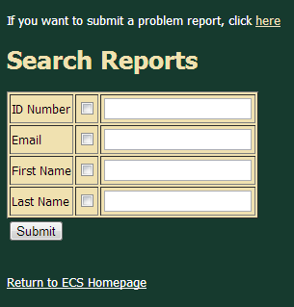

Figure 24: External Problem Report Search Page

This is the External Problem Report Search page. It consists of multiple search categories that the user can select via checking a box. It also contains links to the ECS homepage and a link back to the External Problem Reports Submission page.

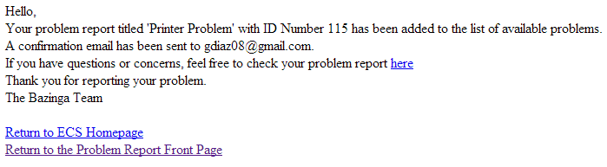

Figure 25: External Problem Reports Confirmation Page

This is the confirmation page that shows up when an external user submits their first problem report. The page contains the unique identification number of the problem report, links in order to contact the administrators of the website, and links back to the Problem Reports Management System website.

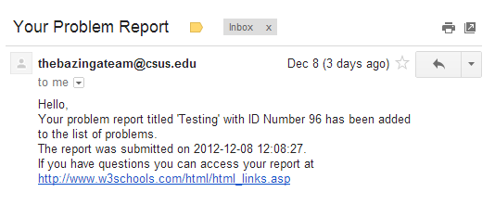

Figure 26: External Problem Reports Confirmation Email

This is the confirmation email that shows up when an external user submits their first problem report. The page contains the unique identification number of the problem report, the date and time of the submission, and a link back to the Problem Reports Management System website.
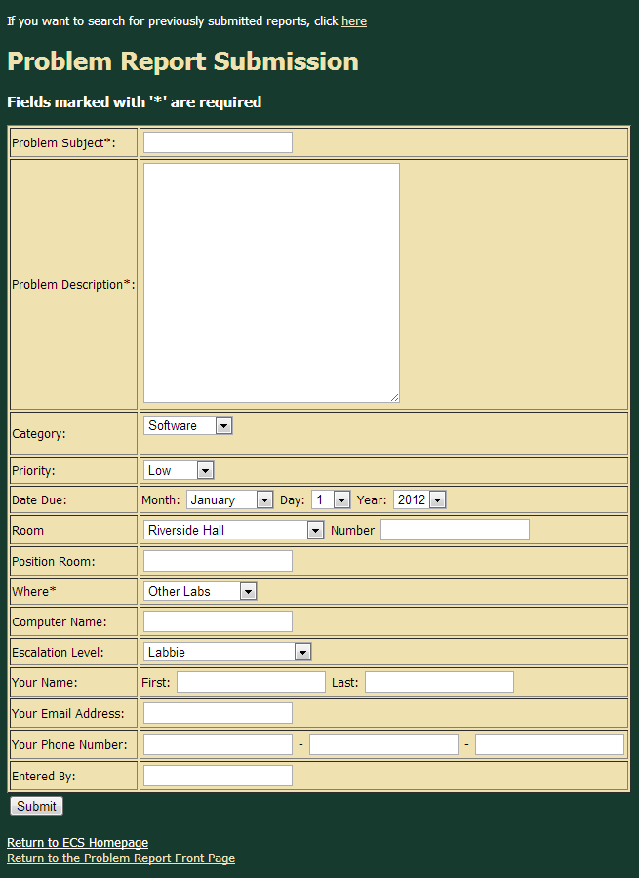

Figure 27: Internal Problem Reports Submission Page

This is the Problem Report Submission page for internal users. It consists of dropdown boxes and fill-in-the-blank features for the user to complete and submit. It also includes a link to search previously submitted reports, a link back the ECS homepage and a link to the welcome page.
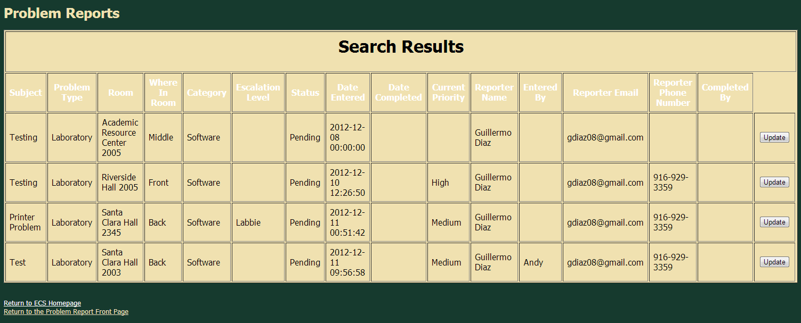

Figure 28: Problem Report Internal Results Page

This is the Problem Report Internal Search Results page. It consists of the all the problem reports that match the search results. In this case the search was done when the room field was filled out as “Riverside.”

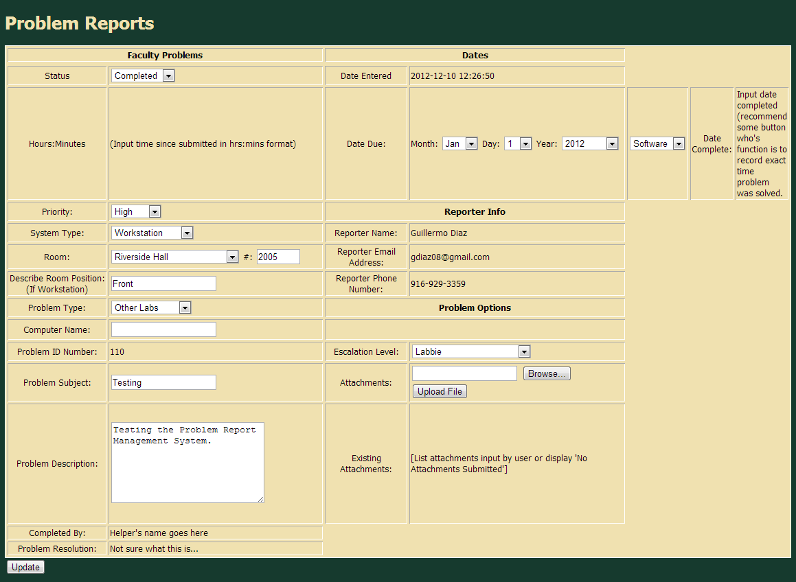

Figure 29: Problem Report Update Status Page

This is the page that allows internal users to update the status or information of the problem report they searched for. It consists of multiple dropboxes including status, data, and category and a few fill-ins such as problem description and subject.
- Programming Tools

There were a number of programming languages and tools that were used during the design and implementation phase of the Problem Reports Management System (PRMS) development cycles. These programming languages and tools are listed below:

- Linux / Windows Operating System: These are our operating systems of choice because these are the operating systems that are widely used by our clientele.

- Athena Web Server: This is necessary because our coding contains PHP therefore a web browser that supports it is necessary for us to test and run our progress.

- Athena MySQL Database: This is the database where the information such as usernames and tables was stored and recorded for later use.

- Notepad++: This programming tool was used for coding our project.

- Apache HTTP Server: This is the server that will host our Problem Report website.

- PHP Programming Language: This is the language that we are using to code the sites for our Problem Report website.

- HeidiSQL: This was the tool that was used to create and manipulate the MySQL database that was stored on the Athena Web Server.

- Restrictions, Limitations, and Constraints

  - Constraints

One constraint is that this application must be delivered by the end of the semester. It also must be coded to function using a MySQL database and an Apache server. Lastly, it is highly preferred by our client that the application be coded with the PHP programming language.

  - Limitations

Some limitations for this team include no previous knowledge of the MySQL database or PHP programming language. The system was also developed with little knowledge in terms of interfacing both the PHP programming language and the MySQL database tool, and was also designed and implemented with little time due to obligations with other classes.

- References or Sources Used

- PHP tutorial to learn the programming language: http://www.w3schools.com/php/default.asp

- Lynne Koropp for questions and concerns about requirements and implementation: lynne@ecs.csus.edu

- Poonam Jadhav for questions and concerns about the MySQL database and PHP language: RVR 2003, Mondays and Thursdays 2-4pm

- Team Member’s Roles and Approval

  - Member Roles

Team member’s roles include meeting up as a team on Monday nights and any additional days to work on the design document and to program code. All team members were unfamiliar with MySQL and were tasked with learning how to use MySQL for this project. Team members worked together to complete the design document as well as final program design layout.

  - Member Signatures

